Game Design Document

# Pistol Tempo

## Concept

This game involves the environment reacting to music, being portrayed through the movements in the environment or the spawning of targets according to the music. It is up to the player to shoot those targets that are spawned in or revealed by the environment. The player will accumulate a score depending on how many targets they shoot.

### Inspiration

This section will talk about the different games that inspired pistol tempo.

#### Beat Sabre

* 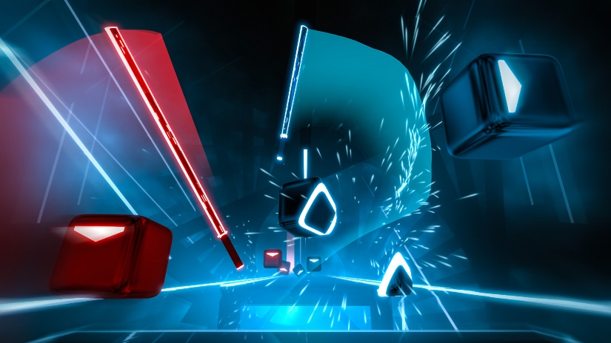This game is VR, and contains a library of music made by the community as well as artists
* The player is in control of 2 lightsabres which they use to slice the boxes that spawn in tandem with the music
* Depending on how the boxes are sliced, they give a score depending how early the boxes are hit

##### **Features I want to adopt**

* Futuristic art style
* Library of music
* Interactive targets

#### BPM

* 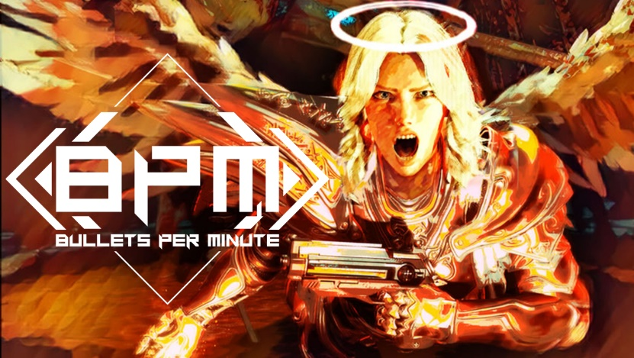Roguelike
* Your goal is to survive hordes of enemies within the dungeon you’re exploring.
* At the same time, you must keep in time with the beat as you shoot and cast spells

##### **Features I want to adopt**

#### Aim Labs

* 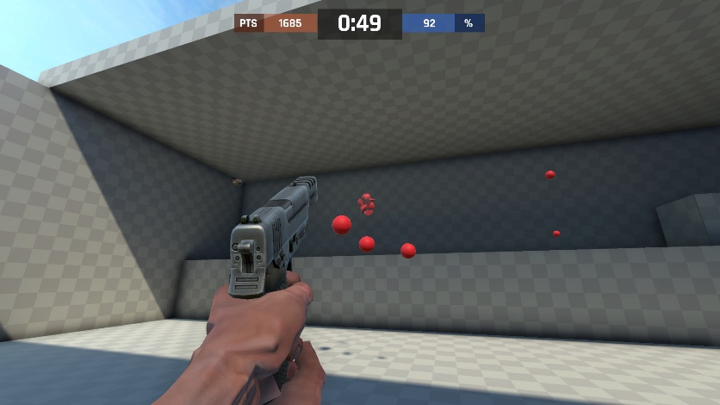This is more tuned to helping people improve their aim in competitive games like CSGO/ VALORANT
* Provides performance information for players, depending on what training exercise they do.

Their shooting experience is fully customisable

### Overview

#### Genre

First Person Shooter, Rhythm Game

#### Target Audience

##### Age

15+

#### Monetization

To be decided whether it will be through adverts or payment for the game

#### Platforms & System Requirements

Designed for the PC

### Theme and Setting

### Project Scope

The final product should be a full game where the player can create their own music to play along to, similar to games like OSU.

### Game Setting

Locations

Story

Backstory

### Characters

The protagonist

Supporting character

### Gameplay & Mechanics

The game play will mostly focus on how the game environment **reacts to music**, I have still to decide whether to have the environment **reveal enemies** or for **targets to appear** at certain points of the music. The **Player** will then have the chance to shoot at the **enemies/targets**

## References

1. <https://store.steampowered.com/app/1048879/Beat_Saber__Feint__We_Wont_Be_Alone_feat_Laura_Brehm/>
2. <https://www.godisageek.com/reviews/bpm-bullets-per-minute-review/>